Customer Dependency Diagram:

Name, ContactNumber, Email -> StreetAddress, Suburb, City

Name -> ContactNumber, Email, StreetAddress, Suburb, City

ContactNumber -> Name, Email StreetAddress, Suburb, City

Email -> Name, ContactNumber, StreetAddress, Suburb, City

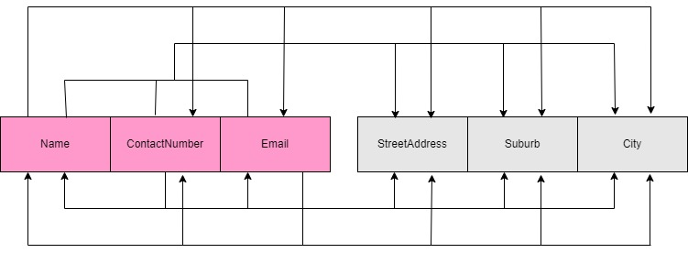

Figure 1

Driver Dependency Diagram:

Name -> City, Deliveries

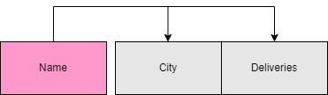

Figure 2

Restaurant Dependency Diagram:

Name, ContactNumber -> City

Name -> City, ContactNumber

ContactNumber -> Name, City

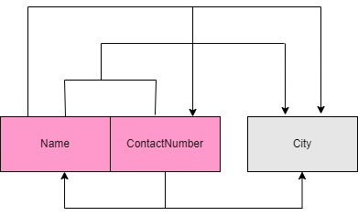

Figure 3

Orders Dependency Diagram:

OrderNumber -> Customer, Driver, Restaurant, ItemOne, QuantityOne, PriceOne, ItemTwo, QuantityTwo, SpecialInstructions



Figure 4